Scallop with Mango Avocado Salsa

By: Anna Bramwell, JWU Student, Junior in Culinary Nutrition & Clinical Dietetics

Scallop with tropical salsa

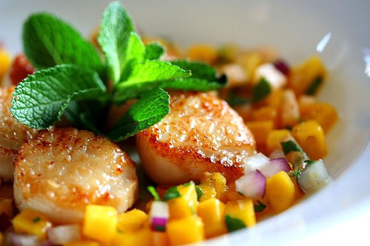

Yield: 4 servings

Ingredients:

Salsa:
1 cup Mango, diced
¼ cup Red pepper, diced
¼ cup Red onion, diced
¼ Avocado, diced
1 Jalapeno diced
1 Tbsp. Fresh cilantro, chopped
1 Tbsp. Lime juice
1 Tbsp. Paprika, ground
1 tsp. Cumin, ground
¼ tsp. Salt
1 tsp. Pepper

Scallop:
16 Fresh sea scallops
Olive oil, as needed

Method of Preparation:

- Cut and toss together all salsa ingredients. Set aside.
- Sauté scallops in a pan with oil for at least 2 minutes on each side. The ridges should be golden brown.
- Plate the scallops and top with a scoop of mango salsa, serve immediately, and enjoy!

Nutritional Analysis: Per serving

Calories: | 490 kcal | Fiber: |  |  | 13 g |  |  | Calcium: |  | 144 mg
Total Fat: | 9 g | Cholesterol: |  |  | 75 mg |  |  | Iron: |  | 6 mg
Saturated Fat: | 1.5 g | Vitamin D: |  |  | 0 mcg |  |  | Sodium: |  | 950 mg
Protein: | 37 g | Potassium |  | 1,611 mg
Carbohydrates: | 25 g

