One Pot Chicken Pesto Pasta

By: Anna Bramwell, JWU Student, Junior in Culinary Nutrition & Clinical Dietetics

Effortless Chicken Pesto Pasta.

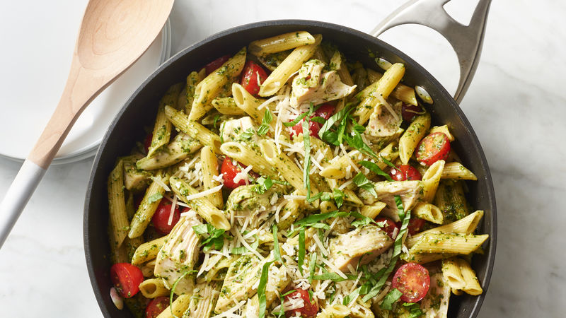

Yield: 4 servings

Ingredients:

1 lb. Boneless chicken thighs
1 tsp. Paprika
1 tsp. garlic powder
½ tsp. salt
1 tsp. Black pepper
Olive oil, as needed
16 oz. Vegetable broth
1 cup Uncooked pasta, your choice
1 cup Broccoli florets
1 cup Cauliflower florets
1 cup Cherry tomatoes halved
1/3 cup Pesto sauce

Method of Preparation:
- Mix chicken thighs with paprika, garlic powder, salt, and pepper.
- In a large sauté pan, heat oil, and add the seasoned chicken, sear evenly on both sides until golden brown; remove from pan.
- Using the same sauté pan, heat the vegetable broth to a boil.
- Add in the pasta, and reduce the heat to a simmer, cook for about 11-12 minutes.
- Add the broccoli, and cauliflower florets and cook covered for 7 minutes.
- Return chicken to the sauté pan and cook covered, 2 minutes or until pasta is tender and chicken is no longer pink, mix occasionally.
- Add the cherry tomatoes, and pesto sauce, heat through and enjoy!

Nutritional Analysis: Per serving

Calories: | 400 kcal | Fiber: |  |  | 4 g |  |  | Sugars: |  | 4 g
Total Fat: | 18 g | Cholesterol: |  |  | 75 mg |  |  | Sodium: |  | 646 mg
Saturated Fat: | 4 g
Protein: | 30 g
Carbohydrates: | 29 g

