Cauliflower Alfredo

By: Megan Bell, JWU Student, Senior in Culinary Nutrition & Clinical Dietetics

Creamy, velvety sauce with intense garlic flavor and low fat content
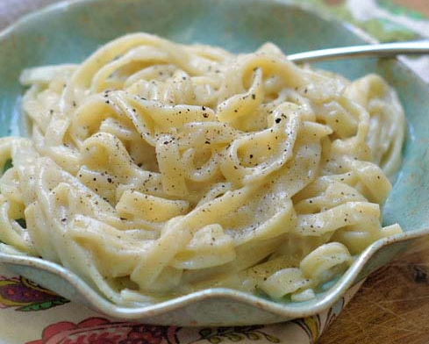

Yield: 5 servings

Ingredients:

2 cups vegetable broth
1 head cauliflower
1 Tbsp butter
6 cloves garlic, chopped
1 pound whole wheat pasta
1 cup starchy pasta water
¼ tsp salt
¼ tsp pepper
1 Tbsp olive oil
¼ cup heavy cream

Method of Preparation:

- Bring vegetable broth to boil over medium-high heat. Core cauliflower and cut into medium size florets; add to broth. Cook until soft, about 15 minutes.
- Meanwhile, melt butter in large sauté pan over medium heat. Add garlic and sauté 4-5 minutes, or until soft.
- Meanwhile, bring large pot of water to boil and cook pasta according to package directions. Reserve some of starchy water to add to sauce later.
- Puree cauliflower with 2 cups broth in blender or with beater. Add garlic, salt, and pepper. Puree until smooth, about 5 minutes. Stream olive oil into blender, adding more broth or water if mixture is too thick. Once smooth, transfer back to sauté pan.
- Add cream and cook over low heat. Add starchy pasta water and keep warm until ready to serve. Combine noodles and sauce in large pot and serve.

Nutritional Analysis: Per serving

Calories: | 434 kcal | Fiber: |  |  | 9.4 g |  |  | Calcium: |  | 59 mg
Total Fat: | 10.3 g | Cholesterol: |  |  | 14 mg |  |  | Iron: |  | 3 mg
Saturated Fat: | 3.4 g | Vitamin D: |  |  | 5 mcg |  |  | Sodium: |  | 473 mg
Protein: | 14.5 g | Potassium |  | 614 mg
Carbohydrates: | 71.5 g

