Veggie Kabobs with Sweet Fruit Sauce
By: Holli Mootz, JWU Student, Senior in Culinary Nutrition & Clinical Dietetics
Sauce is adapted from “Red Currant Sauce”
A light and flavorful side dish
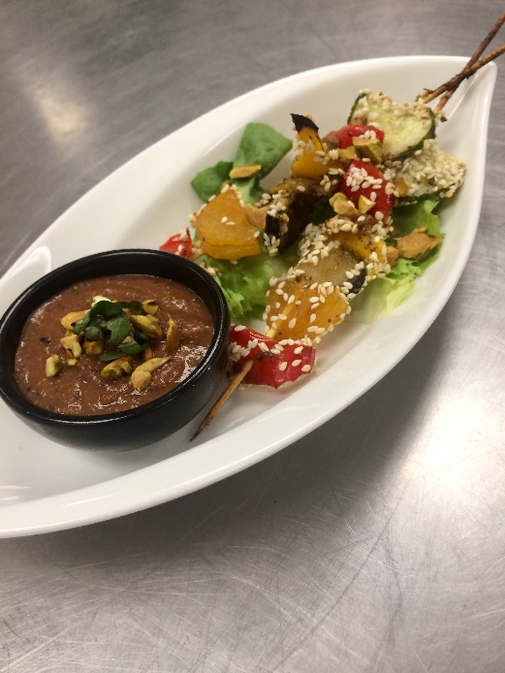
Yield: | 44 ounces/4 servings

Ingredients:

1 cup Pear nectar
¼ cup Currants, dried
3 ounces Apricots, whole, dried
2 Tablespoons Olive oil
1 ½ Tablespoons Italian seasoning
1 Tablespoons Flaxseed meal
1 Tablespoons Water
½ ounces Pickled ginger, rough chop into ½ inch dice
4 ounces Cucumber, thin circles
3 ounces Red pepper, ½ inch dice
4 ounces Eggplant, thin circles and halved
1 mango cut in half, sliced then halved
5 Tablespoons White sesame seeds
¼ teaspoon Salt
5 ounces Strawberries
1 Tablespoon Honey
2 Tablespoons Balsamic vinegar
½ ounces Basil
1 ounce Pistachios

Method of Preparation:

Gather all ingredients and equipment.
Soak skewers and set aside until you are ready to use and preheat oven to 350°F.
Get a small saucepan and measure out and combine the pear nectar, currants, and apricots in it.
Turn on heat and set the pan on the stove until liquid is simmering.
Once simmering, turn off heat and set the fruit to the side to let it rehydrate in the liquid until needed again.
Add Italian seasoning, olive oil, flaxseed meal, water, and combine in a bowl.
Cut all the vegetables and the mango in the appropriate size and add to the bowl of seasonings. Toss the vegetables and set aside.
Measure out the sesame seeds and coat the bottom of a shallow pan or tray with them for rolling.
Take the apricots from the rehydrating liquid and cut them in half or thirds depending on the size and put to the side. Reserve the currants and liquid for the sauce later by setting to the side.
Assemble the fruit and veggies on the skewer (cucumber, pepper, ginger with mango, eggplant, apricot, and repeat until end of stick). Then roll the stick in the sesame seeds for a light coating.
Place on a sheet tray and bake in a 350°F oven for 10 minutes.
Toast pistachios in the 350°F oven for 5 minutes and set aside.
Measure out strawberries, honey, balsamic vinegar, and basil and combine them in the original saucepan with the pear nectar and currants.
Bring to a boil and then lower to low-medium heat until strawberries are soft, and the flavors are blended well together. Stir occasionally, about 15 minutes.
Transfer to a blender with the pistachios (reserve a few pistachios for garnish) and purée until smooth.
Transfer to the serving bowl and garnish with one chiffonade basil and leftover pistachios.

Chef’s Notes/HACCP: Contains seeds, nuts, and mangos. Different seed and nut varieties, like poppy seeds or pecans may be substituted if desired. The mangos can be replaced with papaya if desired. All seeds, nuts, and mangos can be omitted as well. Plate on a single leaf of lettuce, cross the kabobs, and sprinkle the pistachios over the entire dish. Garnish with chiffonade basil and pistachio nuts on top of the sauce in the middle. Use gloves for ready-to-eat food. Hold cold at below 41°F or below or hold hot at 135 °F or above.
Nutritional Analysis: Per serving
Calories: | 321 | Fiber: |  |  | 7 g |  | Calcium: |  | 163 mg
Total Fat: | 12 g | Folate: |  | 43.39 mcg |  |  | Iron: |  | 3.29 mg
Saturated Fat: | 1.6 g | Sodium: |  |  | 198.7 mg |  | Protein: |  | 4.2 g
Mono Fat: | 6.9 g | Vitamin K: |  |  | 26.13 mcg |  | Potassium: |  | 302.2 mg
Carbohydrates | 52 g

