Turkey Stuffed Peppers

By: Anna Bramwell, JWU Student, Junior in Culinary Nutrition & Clinical Dietetics

Zesty ground turkey and vegetables stuffed in a tender bell pepper.

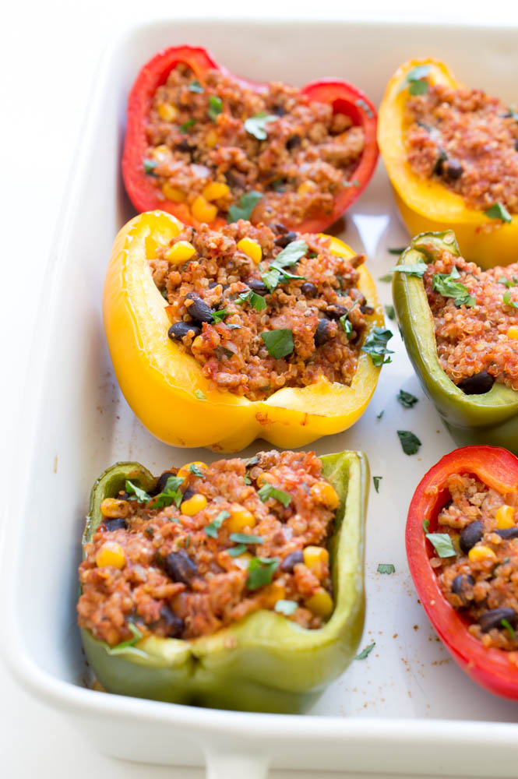

Yield: 6 servings

Ingredients:

1 lb. 93% lean ground turkey
2 garlic cloves, minced
1/4 onion, minced
¾ cup black beans, rinsed and drained
½ cup mushrooms, diced
1/4 cup tomato sauce
1 tsp paprika
½ tsp dried thyme
½ cup frozen corn
3 large red or yellow bell peppers
2 Tbsp olive oil
Pinch of salt and pepper
2 Tbsp fresh basil, chopped
2 Tbsp fresh cilantro, chopped

Method of Preparation:

- Preheat oven to 375 degrees Fahrenheit.
- In a sauté pan brown the turkey.
- When the turkey is browned, add garlic, onion, black beans, mushrooms, tomato sauce, paprika, and dried thyme. Cook covered for 15 minutes, and stir occasionally.
- Add corn and cook uncovered for an additional 2-3 minutes or until all the liquid starts to evaporate.
- Cut peppers in half lengthwise, removing the seeds.
- Drizzle olive oil over peppers, and fill each with 1/2 cup turkey mixture, placing filling side up on a baking sheet.
- Cover with foil. Bake for about 40 minutes or until the peppers become tender.
- Finish with salt and pepper and garnish with chopped basil and cilantro.

Nutritional Analysis: Per serving

Calories: | 221 kcal | Fiber: |  |  | 3 g |  |  | Sugars: |  | 1 g
Total Fat: | 3 g | Cholesterol: |  |  | 61 mg |  |  | Sodium: |  | 248 mg
Saturated Fat: | 1 g
Protein: | 18 g
Carbohydrates: | 19 g

