Oatmeal Jam Bars

By: Megan Bell, JWU Student, Senior in Culinary Nutrition & Clinical Dietetics

Chewy oat bars with fruity hints of apple and strawberry
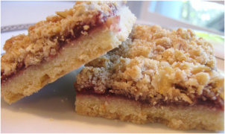

Yield: 16 servings

Ingredients:

1 cup all-purpose flour
1 cup quick oats, uncooked
¾ cup packed light brown sugar
½ tsp baking soda
¼ tsp salt
¼ tsp cinnamon
⅓ cup applesauce
¼ cup strawberry jam or fruit preserves*

*may substitute another flavor

Method of Preparation:

- Preheat oven to 350°F.
- Spray 9” square baking pan with nonstick cooking spray; set aside.
- Combine flour, oats, brown sugar, baking soda, salt, and cinnamon in medium bowl; mix well. Add applesauce; stir with fork until mixture is crumbly.
- Reserve ¾ cup crumb mixture for topping.
- Press remaining crumb mixture evenly onto bottom of prepared pan.
- Bake 5-7 minutes or until lightly browned.
- Spread preserves onto crust; sprinkle with reserved crumb.
- Bake 20-25 minutes or until golden brown.
- Cool completely in pan on wire rack. Cut into 16 squares.

Nutritional Analysis: Per serving

Calories: | 109 kcal | Fiber: |  |  | 0.9 g |  |  | Calcium: |  | 5 mg
Total Fat: | 0.4 g | Cholesterol: |  |  | 0 mg |  |  | Iron: |  | 1 mg
Saturated Fat: | 0.1 g | Vitamin D: |  |  | 0 mcg |  |  | Sodium: |  | 75 mg
Protein: | 1.5 g | Potassium |  | 35 mg
Carbohydrates: | 25.5 g

