Mashed Chickpea “Potatoes” w/ Creamy Mushroom Gravy

By: Megan Bell, JWU Student, Senior in Culinary Nutrition & Clinical Dietetics

A healthy alternative to mashed potatoes and gravy

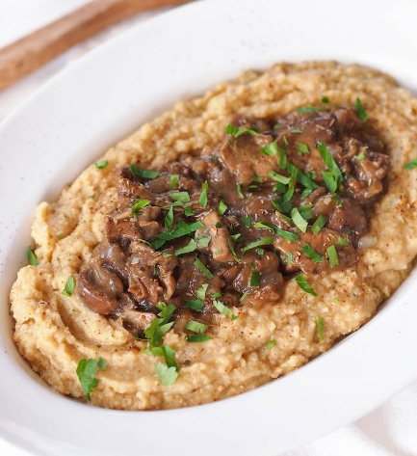

Yield: 6 servings

Ingredients:

Chickpea Puree:
3 cans chickpeas, drained and rinsed, reserve ½ liquid
1 Tbsp olive oil
1 Tbsp lemon juice
½ onion, diced
2 garlic cloves, minced
Salt and pepper

Mushroom Gravy:
1 Tbsp olive oil
16 ounces mushrooms, sliced (foodservice or cremini)
½ onion, diced
2 sprigs fresh thyme
1 Tbsp flour
¼ cup white wine
1 cup vegetable stock

Method of Preparation:

Chickpea Puree:
- Blend chickpeas in food processor until creamy with 1 can chickpea liquid. Season to taste with salt and pepper.
- Heat sauté pan over medium-high heat. Add oil.
- Add onion; cook 3-4 minutes.
- Add garlic; cook 1-2 minutes.
- Add chickpea puree to sauté pan; heat.
- Add more chickpea liquid if needed to achieve desired smooth consistency.

Mushroom Gravy:
- Heat sauté pan over medium-high heat. Add oil.
- Add onion; cook 3-4 minutes.
- Add mushrooms and thyme. Cook about 10 minutes, or until mushrooms are soft.
- Add flour to thicken excess liquid from mushrooms.
- Add white wine. Cook until reduced by ¾.
- Add vegetable stock and cook 5-7 minutes, or until desired consistency is reached (sauce should coat the back of a spoon).
- Season to taste with salt and pepper.
- Serve on top of mashed chickpea “potatoes.”

Nutritional Analysis: Per serving

Calories: | 444 kcal | Fiber: |  |  | 18.7 g |  |  | Calcium: |  | 112 mg
Total Fat: | 11 g | Cholesterol: |  |  | 0 mg |  |  | Iron: |  | 9 mg
Saturated Fat: | 1.3 g | Vitamin D: |  |  | 272 mcg |  |  | Sodium: |  | 39 mg
Protein: | 22.2 g | Potassium |  | 1160 mg
Carbohydrates: | 66.6 g

