Holiday Meatballs w/ Cranberry Dipping Sauce

By: Megan Bell, JWU Student, Senior in Culinary Nutrition & Clinical Dietetics

A festive and nutritious holiday party appetizer

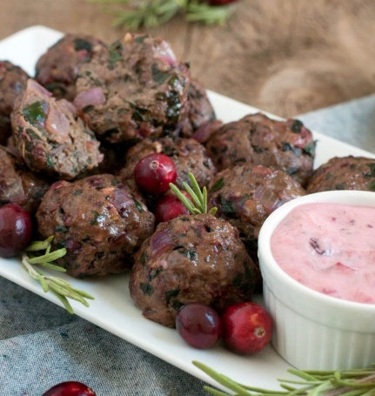

Yield: 4 servings

Ingredients:

Meatballs:
1 tsp olive oil
½ onion, diced
2 cloves garlic, minced
1 cup cranberries, fresh
2 cups kale leaves, packed, stems removed
½ Tbsp dried rosemary
1 pound (90/10) lean ground beef
1 egg
½ tsp salt
¼ tsp pepper

Cranberry Dipping Sauce:
½ cup cranberry sauce
¼ cup light mayonnaise
1 lemon, juiced
2 tsp dried rosemary

Method of Preparation:

Meatballs:
- Preheat oven to 375°F.
- Heat sauté pan over medium-high heat. Add oil.
- Add onion; cook 3-4 minutes.
- Add garlic; cook 1-2 minutes.
- In food processor, combine cranberries, kale, and rosemary. Pulse until finely chopped.
- Add cranberry mixture to sauté pan. Cook 3-5 minutes, or until kale softens.
- Cool mixture 5-10 minutes.
- Combine ground beef and cranberry mixture in bowl.
- Add egg, salt, and pepper.
- Mix well to combine, without overmixing.
- Roll mixture into 2-once balls.
- Line on baking sheet with a wire rack so meatballs cook evenly.
- Bake 15-20 minutes, or until cooked through (155°F).
- Serve with cranberry dipping sauce.

Cranberry Dipping Sauce:
- Add all cranberry dipping sauce ingredients in bowl.
- Mix to combine until well incorporated.
- Chill in fridge at least 1 hour or overnight to develop flavors.

Nutritional Analysis: Per serving

Calories: | 382 kcal | Fiber: |  |  | 3.2 g |  |  | Calcium: |  | 80 mg
Total Fat: | 14.4 g | Cholesterol: |  |  | 146 mg |  |  | Iron: |  | 23 mg
Saturated Fat: | 4 g | Vitamin D: |  |  | 4 mcg |  |  | Sodium: |  | 358 mg
Protein: | 37.4 g | Potassium |  | 740 mg
Carbohydrates: | 24.1 g

