Baked Tofu Stir-Fry with Peanut Sauce
By: Holli Mootz, JWU Student, Senior in Culinary Nutrition & Clinical Dietetics
Adapted from “Crispy Peanut Tofu & Cauliflower Rice Stir-fry”
A healthy and flavorful Thai-inspired meal.
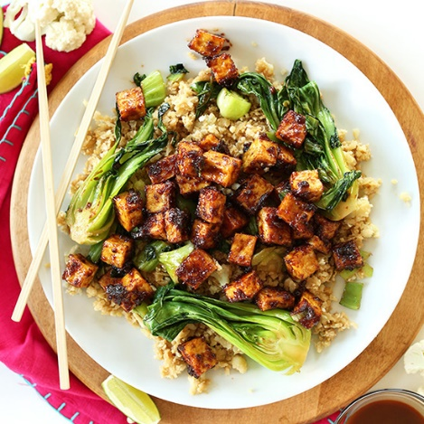

Adapted from “Crispy Peanut Tofu & Cauliflower Rice Stir-fry”

Yield: | 30 oz/ 3 servings

Ingredients:

8 ounces Extra-firm tofu
1 teaspoon Coriander, ground
½ teaspoon Nutmeg, ground
½ cup Sesame oil
2 cups Rice, white or brown
2 cups Water
2 Tbsp Olive oil
1 ½ Tbsp Garlic, minced
1 head, Bok choy, destemmed
1 oz Shiitake mushroom, sliced
1 oz Broccoli. Small florets
½ oz Carrots, small diced
1 oz Snow peas, cut and peeled
Sauce:
2 Tbsp Tamari
½ cup Peanuts, roasted
1 Tbsp Garlic, minced
1 Tbsp Honey
¼ cup Rice vinegar
½ teaspoon Ginger, grated
2-4 Tbsp Water
1/8 teaspoon Crushed red pepper flakes
1 teaspoon Scallions, minced for garnish
Method of Preparation:

Gather all ingredients and equipment.
Drain the tofu for about 1-2 hours by covering it with paper towels, pressing it between two sheet pans, and setting something heavy on top to press the water out. In one hour, preheat oven to 400°F.
Once the tofu is dry, add the coriander, nutmeg, and clove spices to it. Incorporate the flavors into the tofu, then cut the tofu into cubes. Place on parchment lined sheet tray and bake in a single layer for about 25 minutes.
While baking, put on 2 cups of water to boil for the rice and prepare the sauce by blending ½ cup of peanuts in the blender until it turns into butter. Whisk together the rest of the ingredients in a separate bowl, slowly add the homemade peanut butter until the desired consistency is found. Adjust flavors.
Put the 2 cups of rice into the boiling water. Then take tofu out once baked and let cool. Let it seep in the peanut sauce until the rest of the dish is done.
Finish cooking the rice while heating up a sauce pan with olive oil for the vegetables.
Once the pan is hot, add the vegetables to sauté. Once sautéed, turn off heat, plate, garnish with scallions, and serve.

Chef’s Notes/HACCP: Contains peanuts and mushrooms. The dish can have the peanut sauce omitted or substituted if desired. The mushrooms can be omitted or replaced with another vegetable if desired. Plate in a bowl with a wide edge. First put down the rice, then the vegetables with the tofu on top. Drizzle with the peanut sauce and garnish with the scallions. Use gloves for ready-to-eat food. Hold cold at below 41°F or below or hold hot at 135 °F or above.
Nutritional Analysis: Per serving
Calories: | 858 | Fiber: |  | 4.99g |  | Calcium: |  | 107.7 mg
Total Fat: | 65 g | Cholesterol: |  | 0 mg |  | Iron: |  | 2.73 mg
Saturated Fat: | 9.7 g | B-6: |  | .29 mg |  | Sodium: |  | 435.8 mg
Mono Fat: | 27.8 g | Vitamin B-12 |  | 0 mcg |  | Omega 3s: |  | .15 g
Protein: | 21.7 g | Vitamin D |  | .07 mcg |  | Folate: |  | 77.83 mcg
Carbohydrates | 47.1 g | Vitamin K: | 25.26 mcg |  | Potassium: |  | 538.7 mg

